

Presented By:

|  |  |  |  |  |  |  |  |  |
| --- | --- | --- | --- | --- | --- | --- | --- | --- |
| ID | Name | G1 | G2 | G3 | D1 | D2 | D3 | D4 |
| 18106212 | Karim Ahmed Kohel |  |  |  |  |  |  |  |
| 18105818 | Mohamed Osama Badawy |  |  |  |  |  |  |  |
| 18104247 | Omar Tamer Rostom |  |  |  |  |  |  |  |

Smart Home

Department : Computer Engineering

Course Code : CC421

Course Name : Microprocessor Systems

Lecturer : Prof. Ahmed Fahmy

# Summary:

Standards of living are rising due to the rise of technology integration on everything around us in this day and age, which gave us the idea to develop a smart home system for a higher standard of living for the average consumer. The system is both simple and easy to install in any home. The system is highly modular, to accommodate the preferences of each user. It relies on user input to achieve simple tasks around the house like turn on and off electric appliances, users can give commands to the system via a {insert input method} to the main control unit of the system which then sends that command to the specific unit in charge of achieving the task specified by the user (e.g. the specific unit in charge of activating the coffee machine in another room).

# Introduction

[GET IN DETAILS ABOUT THE PROJECT. THIS INCLUDES]

* THE IDEA
* BACKGROUND ABOUT THE MAJOR COMPONENTS (8051 µP, SENSORS,,,)

# Methodology

[GET IN DETAILS HOW IS PROJECT IS DONE]

* HOW THE PROJECT WORKS
* INPUTS AND OUTPUTS
* HOW THE MAJOR COMPONENTS INCLUDED OPERATE
* WHY SOME SPECIFIC COMPONENTS ARE USED (TRANSISTORS, DRIVERS)

# Schematic:

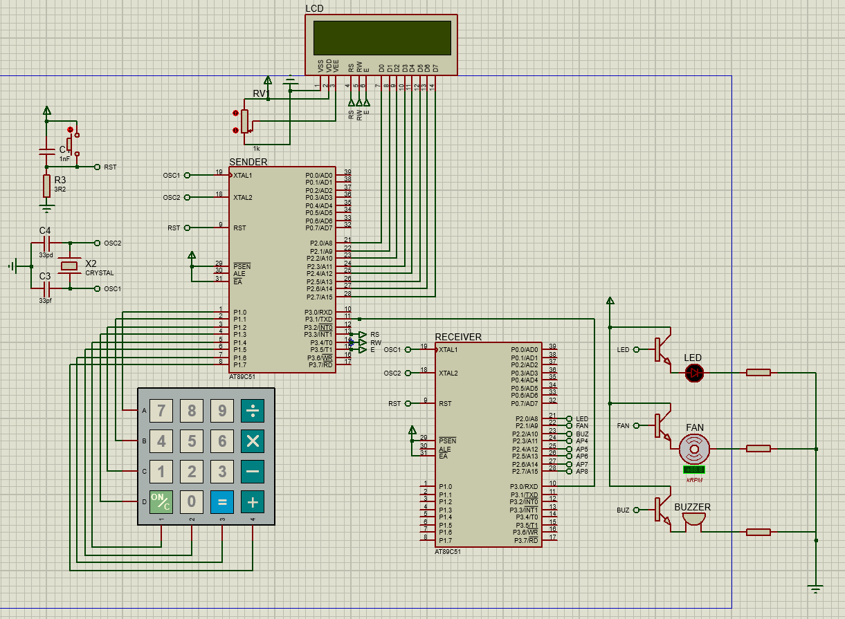

# Components and Tools:

LIST OF ALL THE COMPONENTS USED

# Code Illustration:

AN ILLUSTRATION ABOUT THE OPERATION OF YOUR CODE: (ANY OF THE FOLLOWING)

* FLOWCHART
* PSEUDO CODE

# Code Text:

YOUR ASSEMBLY CODE HERE

# References:

* 8051 instructions
  1. <https://www.keil.com/support/man/docs/is51/is51_instructions.htm>
* 89S52 datasheet
  1. <https://www.keil.com/dd/docs/datashts/atmel/at89s52_ds.pdf>
* Flashing 89S52 with avrdude linux tool
  1. https://www.instructables.com/How-to-Program-8051-Using-Arduino